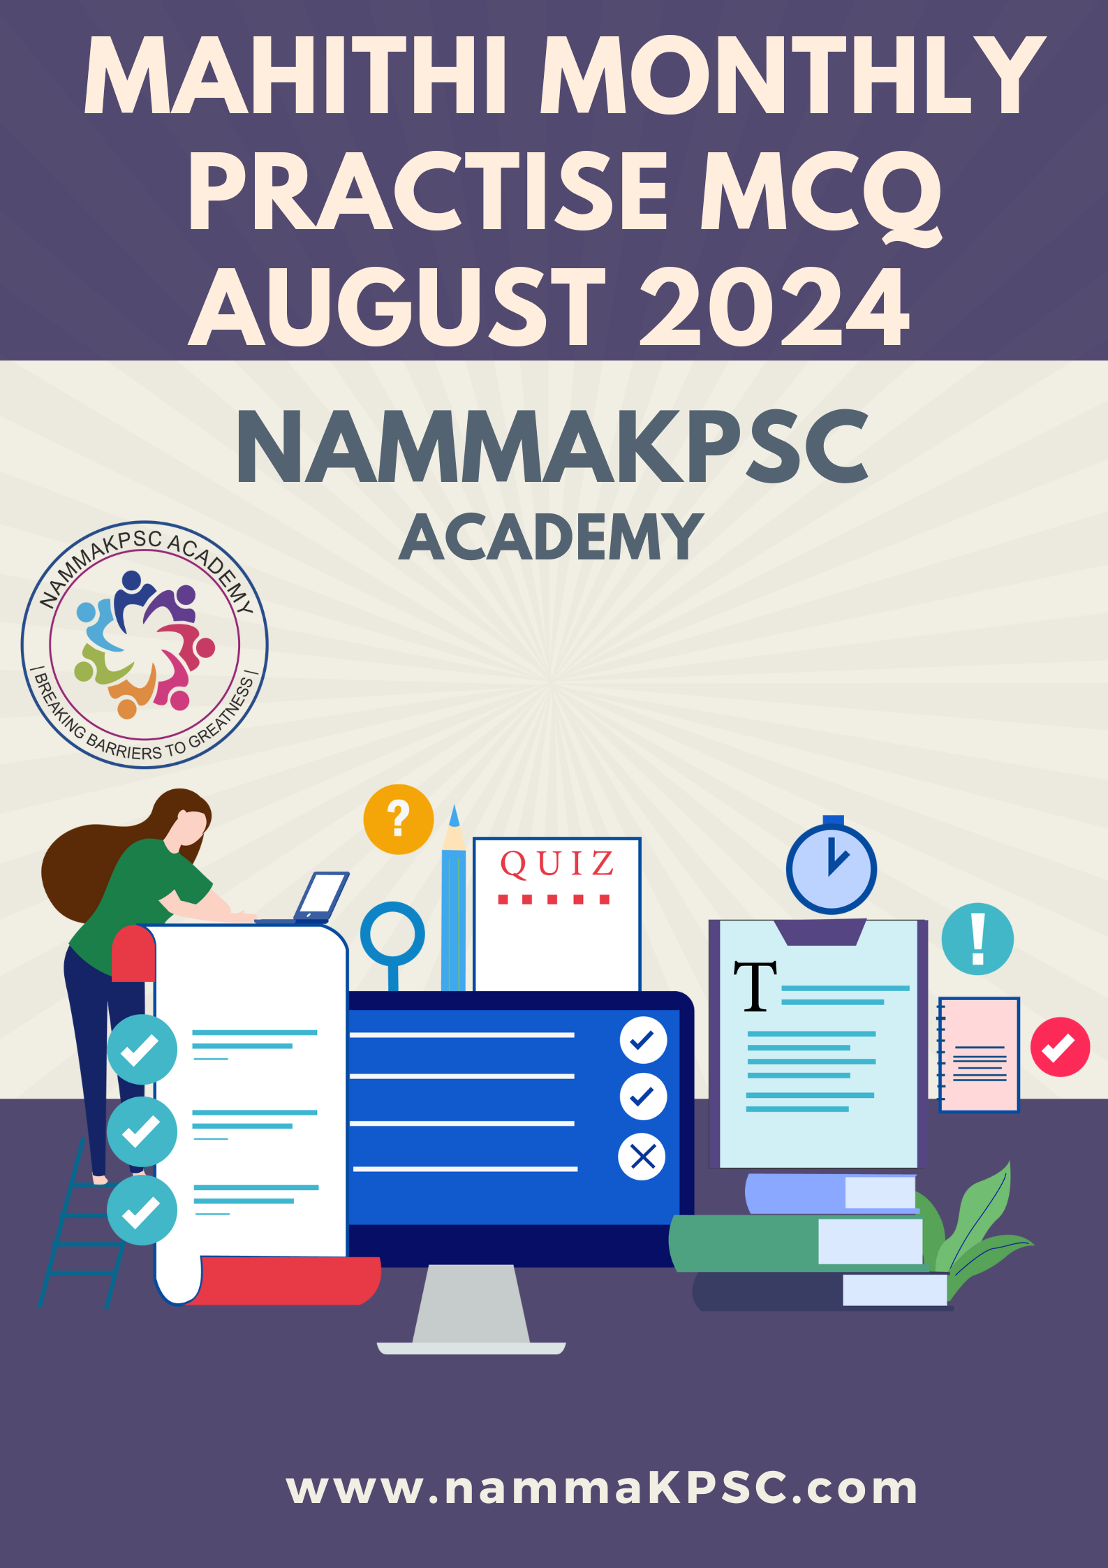
PRACTISE MCQ
1. What is the current share of Karnataka in India's bioeconomy?
a) 10%
b) 15%
c) 20%
d) 25%

2. Karnataka state education department has proposed ’No Bag Day’ on ______
a) Every week
b) Every fortnight
c) Every third Saturday of the month
d) Every month

3. Who is an active partner in the implementation of Mission LiFE?
a) UNICEF
b) MoEFCC
c) YuWaah
d) All of the above

4. What is the name of the technology that allows control of specific brain regions using magnetic fields?
a) Nano-MIND
b) Brain-Net
c) Neuro-Control
d) Magno-Brain

5. What is the main objective of the Bharatiya Vayuyan Vidheyak, 2024?
a) To replace the 1934 Aircraft Act
b) To streamline aviation certification
c) To improve ease of doing business
d) All of the above

6. What is the stipend offered for interns under the Internship Programme?
a) Rs 5,000-10,000 per month
b) Rs 10,000-15,000 per month
c) Rs 15,000-20,000 per month
d) Rs 20,000-25,000 per month

7. Who developed the NATS 2.0 Portal?
a) Ministry of Education alone
b) BoATs/BoPT alone
c) AICTE alone
d) Ministry of Education with support from AICTE and BoATs/BoPT

8. Which instruments accompany the Jhumur dance?
a) Violin and flute
b) Dhol, manjira, and dholki
c) Guitar and drum kit
d) Sitar and tabla

9.Recently, Supreme Court ruling allowed states to sub-classify Scheduled Castes (SCs) Which Articles of the Constitution are mentioned in relation to permissible sub-classification?
a) Articles 15 and 16
b) Articles 21 and 22
c) Articles 45 and 46
d) Articles 341 and 342

10. Which event did Swapnil Kusale win a bronze medal in during his Olympic debut?
a) Men’s 10m Air Rifle
b) Men’s 50m Rifle 3 Position
c) Men’s 25m Pistol
d) Men’s 50m Rifle Prone

11. What is the capacity of the approved Sharavati hydro-pumped storage plant in Karnataka?
a) 1,000 MW
b) 2,000 MW
c) 3,000 MW
d) 4,000 MW

12. What is the main objective of the Women Entrepreneurship Program launched by NSDC?
a) To provide financial grants to women entrepreneurs
b) To empower 25 lakh women entrepreneurs across India
c) To stimulate economic growth and create a supportive ecosystem for women-led enterprises
d) All of the above

13.What is the total area covered by the Draft Notification for the Western Ghats Ecologically Sensitive Area (ESA)?
a) 56,800 square kilometers
b) 50,000 square kilometers
c) 60,000 square kilometers
d) 55,000 square kilometers

14. How do vampire stars rejuvenate?
a) By fusing hydrogen into helium
b) By siphoning material from a companion star
c) By contracting and heating up
d) By expanding and cooling down

15.What is the purpose of the Open Market Sale Scheme (OMSS) introduced by the Food Corporation of India (FCI)?
a) To enhance food security and moderate prices
b) To control inflation and promote healthy eating habits
c) To provide special lunches to schoolchildren
d) To connect major cities and industrial regions to ports and national corridors

16. What is the source of the Delhi L-G's power to nominate aldermen?
a) Article 239AA of the Constitution
b) Delhi Municipal Corporation Act, 1957
c) Council of Ministers' advice
d) The NCT act

17. How many commodities are now monitored by the PMS Mobile App?
a) 22
b) 30
c) 38
d) 40

18. What is the primary responsibility of the state government during natural disasters?
a) Providing central assistance
b) Rescue, relief, and rehabilitation
c) Monitoring fund utilization
d) Declaring national disasters

19. What is a Bailey bridge?
a) A type of modular bridge with pre-built parts for quick assembly
b) A type of permanent bridge
c) A type of suspension bridge
d) A type of cable bridge

20. What is the duration of India's commitment to the WHO Global Traditional Medicine Centre?
a) 4 years
b) 6 years
c) 8 years
d) 10 years

21. Who is collaborating with BBMP on the Suraksha 75 project?
a) World Health Organization
b) World Resources Institute
c) World Bank
d) Asian Development Bank

22.What is the name of the framework launched by QCI to drive excellence among states?
a) QCI Surajya Recognition & Ranking Framework
b) QCI Excellence Framework
c) QCI State Rankings Framework
d) QCI Viksit Bharat Framework

23. Union Health Ministry has released the first-ever SOPs for the transport of human organs .What modes of transport are covered in the SOPs?
a) Air and road only
b) Air and waterways only
c) Road and railways only
d) Air, road, railways, and waterways

24. What is the RBI projected CPI inflation for 2024-25?
a) 4.0%
b) 4.5%
c) 5.0%
d) 5.1%

25.What is the purpose of WHO's Pathogens Prioritisation Report?
a) To provide COVID-19 updates
b) To identify priority pathogens for surveillance and medical countermeasures
c) To develop vaccines for emerging threats
d) To track geographical spread of diseases

26. What are the names of the two drought-tolerant cardamom varieties released?
a) IISR Manushree and IISR Kaveri
b) IISR Kaveri and IISR Appangala
c) IISR Manushree and IISR Madikeri
d) IISR Appangala and IISR Madikeri

27. What is the name of the program launched by the Ministry of Textiles to ensure quality and traceability of cotton?
a) Kasturi Cotton Bharat
b) Cotton Quality Control Program
c) Textile Traceability Initiative
d) Indian Cotton Certification Program

28. How often does Neelakurinji bloom?
a) Once a year
b) Once in 5 years
c) Once in 12 years
d) Once in 20 years

29. What is the duration of the WMO World Weather Research Programme sub-project to enhance weather, water, ice, and climate information in the Arctic and Antarctic regions?
a) 2020-2024
b) 2024-2028
c) 2028-2032
d) 2032-2036

30. What is the main objective of the Clean Plant Programme (CPP)?
a) To promote organic farming
b) To prioritize affordable access to clean plant material for all farmers
c) To enhance agricultural exports
d) To reduce crop losses

31. What is the cure rate of the BPaL regimen, according to preliminary results?
a) 60-65%
b) 70-75%
c) 85%+
d) 90-95%

31. Who is the first recipient of the Vigyan Ratna award?
a) Govindrajan Padmanaban
b) K. VijayRaghavan
c) R. Chidambaram
d) S. Ramakrishnan

33. Which state won the 40th Sub-junior and 50th junior national aquatic championships in Bhubaneswar?
a) Karnataka
b) Maharashtra
c) Tamil Nadu
d) Kerala

34. What is the name of the joint air exercise conducted by the Indian Air Force and Royal Malaysian Air Force at Kuantan, Malaysia?
a) Exercise Udara Shakti 2024
b) Exercise Indian Shakti 2024
c) Exercise Malaysian Shakti 2024
d) Exercise Joint Shakti 2024

35. Where are the Coridius bugs usually found?
a) Arunachal Pradesh
b) Assam
c) Meghalaya
d) Manipur

36. What is the name of the grain ATM launched in Odisha?
a) Annapurna Grain ATM
b) Annapurti Grain ATM
c) Odisha Grain ATM
d) India Grain ATM

37. How much energy does the Omkareshwar Floating Solar Project of Madhya Pradesh generate?
a) 50 MW
b) 90 MW
c) 100 MW
d) 200 MW

38. How many member states are enabled by UNESCO's Intergovernmental Oceanographic Commission?
a) 100
b) 120
c) 150
d) 180

39. Which institution has topped the overall category in the NIRF Rankings 2024?
a) IIT Bombay
b) IISc Bengaluru
c) IIT Madras
d) IIM Ahmedabad

40. What is one of the measures outlined in the Bengaluru Charter to minimize human-wildlife conflict?
a) Formulating a Standard Operating Procedure (SOP) for minimizing conflict
b) Providing compensation for crop losses
c) Tracking elephant herds
d) All of the above

41. What is the eligibility criteria for a village to be selected as a Model Solar Village?
a) Population size above 1,000
b) Population size above 5,000
c) Population size above 10,000
d) Population size above 20,000

42. What is a key component of the Jiyo Parsi Scheme?
a) Medical assistance for Parsi couples
b) Financial assistance for higher education
c) Economic support for Parsi entrepreneurs
d) Cultural exchange programs

43. What is the total number of Ramsar sites in India?
a) 75
b) 80
c) 85
d) 90

44. What does Madhav Gadgil recommend for Wayanad's rehabilitation?
a) Large-scale tourism development
b) Goa's model of homestay tourism
c) Mining activities expansion
d) No rehabilitation efforts

45. What is the National Pest Surveillance System (NPSS) powered by?
a) Machine Learning
b) Blockchain
c) Internet of Things
d) Artificial Intelligence

46. What is the primary mode of mpox transmission?
a) Airborne
b) Direct contact with body fluids or lesions
c) Indirect contact with contaminated items
d) Both b and c

47. Indian astronomers discovered a new correlation using 100 years of solar data from Kodaikanal Solar Observatory. What is the new precursor method based on?
a) Solar wind speed
b) Width of supergranular cells on the solar surface
c) Sunspot area
d) Coronal mass ejections

48. What is INS Arighat?
a) India's second nuclear-powered submarine
b) India's first nuclear-powered submarine
c) India's first conventionally powered submarine
d) India's first aircraft carrier

49. Where is St Martin's Island located?
a) In the southwestern region of the Bay of Bengal
b) In the central region of the Bay of Bengal
c) In the northeastern region of the Bay of Bengal
d) Outside the Bay of Bengal

50. Who is the recipient of a non-posthumous Kirti Chakra in 2024?
a) Colonel Manpreet Singh
b) Rifleman Ravi Kumar
c) Major Malla Rama Gopal Naidu
d) DSP Humayun Muzammil Bhat

51. What is the primary goal of the Pacific Islands Forum (PIF)?
a) Promote economic growth and regional cooperation
b) Address climate change
c) Enhance political governance
d) All of the above

52. What is the name of the phenomenon where small gas bubbles in a liquid emit a brief flash of light when exposed to intense sound waves?
a) Sonoluminescence
b) Bioluminescence
c) Chemiluminescence
d) Radioluminescence

53. What is the Hayflick limit?
a) The maximum number of times a cell can divide
b) The minimum number of times a cell can divide
c) The average number of times a cell can divide
d) The total number of cells in the human body

54. What is the name of Mastercard's new service that uses device-based biometric authentication methods?
a) Secure Payment Service
b) Biometric Authentication Service
c) Payment Passkey Service
d) Transaction Management Service

55. What is Eri Silk known for?
a) Being the world’s only vegan silk
b) Being made from synthetic materials
c) Being produced in South America
d) Being the most expensive silk in the world

56. Which film won the Best Feature Film at the 70th National Film Awards?
a) Kantara (Kannada)
b) Aattam (Malayalam)
c) Kutch Express (Gujarati)
d) Uunchai (Hindi)

57. What is the main objective of Malaysia's "Orangutan Diplomacy" policy?
a) To export orangutans to other countries for research purposes
b) To gift orangutans to palm oil-buying countries to strengthen diplomatic ties
c) To create artificial habitats for orangutans in Malaysia with WEF help
d) To import pandas for wildlife conservation

58.What is the Colombo Security Conclave (CSC)?
a) A trade agreement among South Asian countries
b) A financial collaboration among Indian Ocean nations
c) A regional security grouping comprising India, Sri Lanka, Maldives, and Mauritius
d) A cultural exchange program between India and its neighbors

59. What sustainable alternative to toxic organic solvents did researchers at IISc develop for industrial syntheses?
a) Green polymers
b) CNSL-1000-M surfactant
c) Biodegradable plastics
d) Organic catalysts

60. Which type of cybercrime was most prevalent in Bengaluru Rural district between 2020 and 2024?
a) Online job fraud
b) Courier scams
c) Investment fraud
d) Phishing scams

61. Which organization provided a ₹5,500 crore loan for the Cauvery Stage V Project?
a) World Bank
b) Asian Development Bank
c) Japan International Cooperative Agency (JICA)
d) United Nations

62. Bengaluru is set to develop three integrated townships. Which organization is responsible for notifying land for acquisition for the new townships?
a) BWSSB
b) GBDA
c) Namma Metro
d) BMRDA

63. Which institute is responsible for implementing the RESET Programme?
a) National Institute of Sports
b) Indian Olympic Association
c) Lakshmibai National Institute of Physical Education
d) Sports Authority of India

64. What is the primary objective of the National Industrial Corridor Development Programme?
a) Developing new industrial cities as Smart Cities
b) Developing rural areas
c) Enhancing agricultural output
d) Promoting tourism

65. The Vigyan Dhara Scheme merges how many umbrella schemes?
a) Two
b) Three
c) Four
d) Five

66. When will the Unified Pension Scheme (UPS) come into effect?
a) April 1, 2024
b) April 1, 2025
c) January 1, 2025
d) April 1, 2026

67. What is the Bhavishya software introduced by the DOPPW?
a) A centralized pension processing software
b) A payroll management system
c) A retirement planning tool
d) A grievance redressal portal

68. What percentage of literacy in a State or Union Territory is considered "full literacy" according to the Education Ministry?
a) 90%
b) 95%
c) 85%
d) 100%

69. What is the primary purpose of the SHE-BOX Portal?
a) To provide job opportunities for women
b) To promote gender equality in education
c) To offer financial aid to women
d) To register complaints related to sexual harassment at the workplace

70.What is the new loan limit under MUDRA's Tarun category as per the Union Budget 2024?
a) Rs 10 lakh
b) Rs 15 lakh
c) Rs 20 lakh
d) Rs 25 lakh

71. When was the ASBA facility introduced by SEBI?
a) 2006
b) 2007
c) 2008
d) 2009

72. When was the Pradhan Mantri Jan Dhan Yojana (PMJDY) launched?
a) August 28, 2014
b) September 1, 2014
c) August 28, 2015
d) September 1, 2015

73. What period do the Maharashtra geoglyphs date back to?
a) Bronze Age
b) Mesolithic period
c) Iron Age
d) Neolithic period

74. When did the Wild Life (Protection) Amendment Act, 2022 come into force?
a) January 1, 2022
b) April 1, 2023
c) July 1, 2023
d) October 1, 2022

75. What is the main goal of the Polaris Dawn Mission?
a) To establish a permanent space station
b) To land on Mars
c) To launch a new space shuttle
d) To conduct the first non-government spacewalk at a record altitude

76. What is the primary feature of the RHUMI-1 rocket?
a) Hybrid propulsion system
b) Liquid propulsion system
c) Solid propulsion system
d) Nuclear propulsion system

77. What is ISDra2TnpB?
a) A new type of CRISPR protein
b) A genome-editing tool derived from Deinococcus radiodurans
c) A gene therapy technique for humans
d) A crop enhancement fertilizer

78. Which countries are members of the CSC?
a) India, Sri Lanka, Maldives, and Mauritius
b) India, Pakistan, Bangladesh, and Nepal
c) India, China, Sri Lanka, and Bangladesh
d) India, Maldives, Seychelles, and Bhutan

79. What is the main objective of the Diamond Imprest Licence introduced at the 40th India International Jewellery Show 2024?
a) To increase the export of uncut diamonds
b) To allow eligible exporters to import up to 5% of their average turnover in cut and polished diamonds
c) To encourage the transfer of imported diamonds post-export
d) To reduce the value addition requirement for imported diamonds

80. Who will lead the Karnataka head dam safety panel?
a) SK Kanta
b) Govind Mohan
c) Rakesh Singh
d) Dr. Ram Narain Agarwal

ANSWER
1.c
2.c
3.d
4.a
5.d
6.b
7.d
8.b
9.a
10.b
11.b
12.d
13.a
14.b
15.a
16.b
17.c
18.b
19.a
20.d
21.b
22.a
23.d
24.b
25.b
26.a
27.a
28.c
29.b
30.b
31.c
32.a
33.a
34.a
35.a
36.b
37.b
38.c
39.c
40.d
41.b
42.a
43.c
44.b
45.d
46.d
47.b
48.a
49.c
50.c
51.d
52.a
53.a
54.c
55.a
56.b
57.b
58.c
59.b
60.a
61.c
62.d
63.c
64.a
65.b
66.b
67.a
68.d
69.d
70.c
71.c
72.a
73.b
74.b
75.d
76.a
77.b
78.a
79.b
80.c

